**Automatic Protection of Clothes From Rain**

**19CS65C-PRODUCT DEVELOPMENT LABORATORY**

**Submitted by**

**M.NIRMALA SELVI-201201**

**M.R.SHENBAGALAXMI-2012013**

**K.ANJANA-2012401**

**In partial fulfillment for the award of the degree**

**of**

**BACHELOR OF ENGINEERING**

**in**

**COMPUTER SCIENCE AND ENGINEERING**



**NATIONAL ENGINEERING COLLEGE**

**(An Autonomous Institution, Affiliated to Anna University – Chennai) K.R. NAGAR, KOVILPATTI – 628 503**

**MAY 2023**

i

**BONAFIDE CERTIFICATE**

This is to Certify that this project report “Automatic Protection of Clothes From Rain“ is the bonafide work of NIRMALA SELVI.M (2012011),SHENBALAXMI.M.R (2012013), ANJANA.K (2012401) who carried out the project work under my supervision

**SIGNATURE Mr.A.SHENBAGHARAMAN,M.E., Asstiant. Professor,**

Department of CSE,

National Engineering College

(An Autonomous Institution),

K.R. Nagar, Kovilpatti:628503.

**SIGNATURE**

**Dr. V. GOMATHI, M.Tech., Ph.D.,** Professor & Head, Department of CSE, National Engineering College (An Autonomous Institution), K.R.Nagar, Kovilpatti:628503.

Submitted to the **PRODUCT DEVELOPMENT LABORATORY (19CS67C)** Viva-Voce Examination held at **National Engineering College**, **K.R. NAGAR, KOVILPATTI** on …………………………

**Internal Examiner Co Examiner**

ii

**ACKNOWLEDGEMENT**

First and foremost, we would like to thank God Almighty for showering his blessings throughout our life. He has been the tower of our strength in each step of our work. We take the privilege to express hearty thanks to our parents for their valuable support and effort to complete the project work.

We would like to express our deep sense of gratitude and respectful regards to our director **Dr. S. Shanmugavel B.Sc., D.M.I.T., Ph.D.,** for giving an opportunity to do this work.

We have great pleasure in acknowledging our Principal **Dr. K. Kalidasa Murugavel, M.E., Ph.D.,** for extending his full support to undergo this work.

We express our profound thanks to our beloved Head of the Department **Dr. V. Gomathi., M. Tech., Ph.D.,** for extending her full support and providing facilities during the project work.

We would like to thank our project guide **Mr**.**A.SHENBAGHARAMAN,M.E.,Assistant.Professor**. Department of CSE, whose valuable guidance, technical support and suggestions helped us for doing the project work.

We would like to thank our project guide**, Dr. M. Syed Rabiya, B.E, M.E.Ph.D, Asst. Professor**, Department of CSE, whose valuable guidance, technicalsupport and suggestions helped us for doing the project work.

We extend our hearty thanks to our tutors and class in-charges for their valuable guidance. We are grateful to all the staff members and our dear friends for their valuable suggestion and co-operation for this project work.

iii

**CHAPTER NO. TITLE PAGE NO.**

**ABSTRACT**

**1. INTRODUCTION** 1

**2. LITERATURE SURVEY** 5

**3. DESIGN THINKING** 8

3.1 EMPATHY MAP 9

3.2 CUSTOMER JOURNEY MAP 10

**4. PROPOSED METHODOLOGY**  11 4.1 MODULES 14

4.2 MODULE DESCRIPTION 15

**5. SYSTEM REQUIREMENTS** 16 . 5.1 SOFTWARE REQUIREMENTS 16 . 5.2 HARDWARE REQUIREMENTS 17

**6. IMPLEMENTATION AND RESULT** 246.1IMPLEMENTATION 24

6.2 EXPERIMENTAL RESULT 26

**7. CONCLUSION** 27 **. REFERENCES** 29

iv

**LIST OF FIGURES**

**FIGURE NO FIGURE DESCRIPTION PAGE NO**

3.1 EMPATHY MAP 9

3.2 CUSTOMER JOURNEY MAP 10

4.1 USE CASE DIAGRAM 11

4.2 CLASS DIAGRAM 12

4.3 SEQUENCE DIAGRAM 13

5.1 SOFTWARE REQUIREMENTS 16

5.2 HARDWARE REQUIREMENTS 17

6.1 IMPLEMENTATION PHASE 24

6.2 OUTPUT PHASE 23

v

**ABSTRACT**

As the advancement in science &amp; technology is developing, the human comfort &amp;

needs are also increasing proportionally. As all the branches of engineering are working on fulfill these needs and among all those the “ELECTRONICS” is one of the most important branches to respond to these needs. This paper entitled “AUTOMATIC PROTECTION OF CLOTHES FROM RAIN” is small step towards the comfort ability and save our time. By considering above views, which encourage us to choose such a project. Though this project is low cost, easy to understand &amp; simple in construction, this project helps for next generation.

vi

**CHAPTER 1**

**INTRODUCTION**

Now days it’s difficult to predict the changes in season especially during rainy season. In rainy season it’s very rare that we can find sun rays to dry our clothes but how it possible to make our clothes to expose to sun rays as soon as it available. So there is need for human intervention who continuously monitors this. Keeping a person continuously watching for sun rays is too much stupidity as a waste of time. Hence there exists an electro mechanical system which continuously monitors the sun rays and rainy season and automatically take back the clothes from sun rays to protect from wet. In this project there exists tray which opens &amp; close based on sun rays. Tray is fixed on roof and controlled through 8 bit microcontroller which recognizes this status of weather. This paper is based on the project which is an embedded system consisting of 8 bit microcontroller and sensing system. Sensing system is implemented using Rain Sensor with Buzzer. The sensing system is fixed on roof and tray is fixed just below the roof.

Rainy weather can be a real inconvenience, especially when it comes to keeping our clothes dry. Whether we're walking to work, running errands, or simply enjoying a leisurely stroll outdoors, the threat of getting caught in a downpour can leave us feeling anxious and unprepared. Fortunately, advances in technology have made it possible to automatically protect our clothes from rain.

Automatic protection from rain can take many forms, including waterproof and water-resistant materials, specialized coatings, and even electronic devices that actively repel water. These innovations have made it possible for us to enjoy outdoor activities without having to worry about getting wet or ruining our clothes.

1

One popular method of automatic protection is the use of waterproof materials. Waterproof fabrics, such as Gore-Tex, are designed to keep water from penetrating the fabric by using a membrane or coating that repels water.

This means that raindrops simply roll off the surface of the fabric, keeping the wearer dry and comfortable. Waterproof materials can be found in a wide range of clothing items, from jackets and pants to shoes and bags.

Another approach to automatic protection is the use of water-resistant materials. These materials are designed to repel water to a certain extent, making them ideal for use in lighter rain or drizzle. Water-resistant materials are often treated with a special coating that helps water to bead up on the surface of the fabric, rather than penetrating it. This allows the fabric to remain breathable, while still providing a level of protection against moisture.

In addition to these more traditional approaches, there are also a number of innovative electronic devices that can help to protect our clothes from rain. For example, there are special umbrellas and raincoats that use electronic sensors to detect raindrops and automatically expand or adjust their coverage accordingly. There are also specialized sprays and coatings that can be applied to clothing to make them water-repellent.

Protecting clothes from rain is a common problem that people face, especially in areas with frequent rainfall. Traditional raincoats and umbrellas are commonly used to protect against rain, but they have their limitations, such as being bulky, cumbersome, or not always convenient to carry around.

2

To address this issue, there has been a growing interest in developing automatic protection for clothes from rain. Automatic protection involves the use of technology to create materials or products that can repel water, keeping clothes dry and protected without the need for additional accessories.

One of the most promising approaches to automatic protection of clothes from rain is through the use of hydrophobic coatings. These coatings are designed to repel water by creating a barrier on the surface of the fabric that prevents water droplets from penetrating it. This technology has already been used in some consumer products, such as self-cleaning windows and waterproof mobile phones.

Another approach to automatic protection of clothes from rain is through the use of nanotechnology. By creating microscopic structures on the surface of fabrics, researchers have been able to create materials that repel water and prevent it from soaking through. These materials have shown promise in lab tests, but their effectiveness in real-world conditions still needs to be evaluated.

In addition to these technologies, some companies have been exploring the use of smart textiles for automatic protection of clothes from rain. These textiles can sense when they are exposed to moisture and respond by tightening up to create a barrier against water. This technology is still in its early stages of development, but it has the potential to revolutionize the way we protect our clothes from rain.

the development of automatic protection for clothes from rain has the potential to improve our daily lives by eliminating the need for traditional rain protection accessories and keeping us dry and comfortable in wet weather. As technology continues to evolve, we can expect to see more innovative solutions emerge to tackle this common problem.

3

**1.1Motivation:**  We decided to make an Automatic based project which protects clothes from being wet during without any human being, We chose this project as it is a basic problem in the region where it rains heavily. It consists of microcontroller and some other sensors based on the embedded program we are going to frame a controller that fulfills our automation work of our project.

Hence there exists an electro mechanical system which continuously monitors the sun rays and rainy season and automatically take back the clothes from sun rays to protect from wet. In this project there exists tray which opens & close based on sun rays. Tray is fixed on roof and controlled through 8 bit microcontroller which recognizes this status of weather. This paper is based on the project which is an embedded system consisting of 8 bit microcontroller and sensing system. Sensing system is implemented using LDR. The sensing system is fixed on roof and tray is fixed just below the roof

4

**CHAPTER 2**

**LITERATURE SURVEY**

**M. Ucar, H.M. and O. Turkoglu** implementation of rain sensitive triggering system for wind shieldwiper motor. Automotive windshield wiper systems have three main components, which are wiper arms, connection mechanism and an electric motor that drives this mechanism.The sensors are located on the windshield and are operated based on the feature of the rainsquall's weak electric conductivity. The experimental results based on a single sensor show the reliability of the system.

**Hagit Messer; Artem** implement Environmental sensor networks using existing wireless communication. The microwave links that form a wireless communication network (WCN) for a cellular network infrastructure can be considered for an environmental sensor network (ESN). Every radio link that connects a base station to the core network is a sensor. For such an ESN, the key challenge is to develop algorithms to estimate the intensity of weather effects that impair communication performance - first rainfall and wind, and then, humidity. fog, and snow.

**Kyoo Nam Choi** implement Omni-directional rain sensor utilizing scattered light detection reflected by rain or moisture on windshield glass is realized, while conventional rain sensor senses disturbances at point or line on windshield glass along light path. Modulated light from light source is emitted without directional pattern, and photodiode to prevent direct propagation to photodiode. Time division sensing algorithm was used to discriminate raining intensity in 7 steps to apply as rain sensor in automobile. Experiments using simulated rain facility showed possibility as rain sensor for automotive application.

**Vijayen S. Veerasamy** to design the Rain sensor for detecting rain or other material on window of a vehicle or on other surface. A system and method for sensing the presence of moisture.In certain example embodiments, a capacitor-based system and/or method is provided

5

for auto- correlating sensor data to determine the existence of a material on the window. In

certain example embodiments, the system and/or method may perform check(s) to enhance

the accuracy of the detection by comparing.

**S. Czarnocki** automotive pressure sensor is one of the most widespread applications of a micromachined device, and has evolved into a relatively mature technology, expanding beyond its original use as an engine control sensor into other vehicle control and diagnostic systems. This paper shows how the commercial success of a product using microfabricated technology is highly dependent upon other core competencies, beyond just the capability to perform the micromachining operations necessary to create the sensing device.

In study by **Pearson.D** they implement a rain detector attempts have been made to detect rain based on its effect on the resistance and capacitance. between electrodes deposited on the wind shield. Sensoos based on these methods are integrated with the wind-shield and are potentially less expensive and less conspicuous. The capacitive sering method relies on the relatively large dielectric constant of water as it affects the capacitance between conductive electrodes.

In their study, **Hochstein.P.A.** Vehicle sensor to detect rain drop on and above waveguide utilizing light deflection and scattering was realized, keeping wide sensing coverage and sensitivity to detect mist accumulation. Proposed sensor structure under stacked light wave guide consisted of light blocking fixture surrounding photodetector and adjacent light source.

**Hagit Messer** et al Environmental sensor networks using existing wirelesscommunication systems for rainfall and wind velocity measurements The microwave links that form a wireless communication network (WCN) for a cellular network infrastructure can be considered for an environmental sensor network (ESN). Every radio link that connects a base station to the core network is a sensor. For such an ESN, the key challenge is to develop algorithms to estimate the intensity of weather effects that impair communication performance - first rainfall and wind

6

Superhydrophobic Coatings for Textiles: A Review, by **Dongyeop X**. Oh and Young-Seak Lee. This article, published in the journal Coatings in 2020, provides an overview of the technology behind superhydrophobic coatings for textiles, including how they work, their benefits, and their limitations.

Textile-Based Waterproofing and Moisture Management: A Review, by **Adil I. Bhatti, Abher Rasheed,** and **Sanjay Gupta**. This article, published in the journal Textile Research Journal in 2021, provides an overview of various approaches to waterproofing textiles, including coatings, laminates, and finishes.

Evaluation of water repellency of fabrics coated with nano-hydrophobic materials, by **V. Subramanian, R. Vasanthakumar, and S. Kumaravel**. This article, published in the Journal of Industrial Textiles in 2018, presents the results of a study on the effectiveness of nano-hydrophobic coatings for protecting textiles from water.

Development of a durable and efficient superhydrophobic textile by spraying with SiO2 nanoparticles and fluoroalkylsilane,by **Hyeon Woo Lee, Seung Yong Lee, and Hee Dong Jang.** This article, published in the Journal of Industrial and Engineering Chemistry in 2019, presents a method for creating a superhydrophobic textile using a combination of SiO2 nanoparticles and fluoroalkylsilane.

Waterproof breathable textiles: A comprehensive review,by **Jingjing Wang, Jun Yang, and Zonglin Chu.** This article, published in the Journal of Cleaner Production in 2018, provides an overview of the various types of waterproof breathable textiles available, including their properties, advantages, and disadvantages.

7

**CHAPTER 3**

**DESIGN THINKING**

**3.1 EMPATHY MAP:**

An empathy map is a collaborative tool teams can use to gain a deeper insight into their customers. Much like a user persona, an empathy map can represent a group of users, such as a customer segment. Traditional empathy maps are split into 4 quadrants (Says, Thinks, Does, Feels).

**Advantages:**

⮚ More understanding of the Target Audience

⮚ More organized information in easy-to-understand format ⮚ Fast and Inexpensive

⮚ Easy Customization

⮚ Common understanding and same mindset of whole team members ⮚ Empathy map describes what user think, says, feel, does

**Disadvantages:**  ⮚ There was often overlap between what our users sees and hears. ⮚ Also attendees would struggle to express what the user gains. ⮚ In essence, they were perfect for general customer segment.

⮚ But they were too generic for a workshop focused on user experience.

8

**3.1.1 Empathy Map Diagram:**

Empathy map for Automatic protection clothes from rain using Internet of

Things is represented in the figure 3.1.

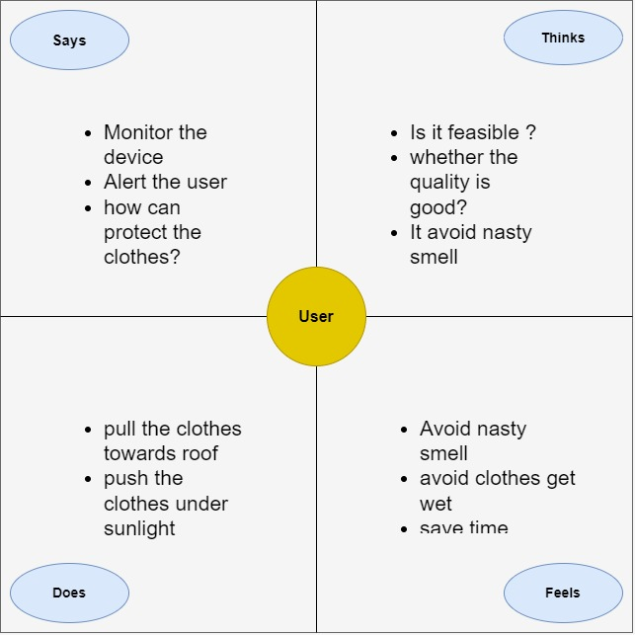

Figure 3.1 Empathy Map Diagram

9

**3.2CUSTOMER JOURNEY MAP**

A customer journey map is a very simple The microwave links that form a wireless communication network (WCN) for a cellular network infrastructure can be considered for an environmental sensor network (ESN). Every radio link that connects a base station to the core network is a sensor. For such an ESN, the key challenge is to develop algorithms to estimate the intensity of weather effects that impair communication performance - first rainfall and wind, and then, humidity, fog, and snow. It is a diagram that illustrates the steps that customers go through in engaging with a company, whether it be a product, an online experience, retail experience, or a service, or any combination. The more touch points the company has, the more complicated but necessary such a map becomes. Sometimes customer journey maps are “cradle to grave,” looking at the entire arc of engagement.

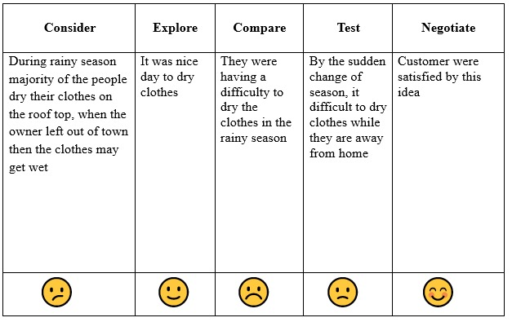

Figure 3.2 Customer Journey Map

10

**CHAPTER 4**

**PROPOSED METHODOLOGY**

The proposed automatic protection system deals with the protection of

clothes from rain. The project is carried out in OpenCV environment using sensors

and motors.

**4.1ARCHITECTURE DIAGRAM USE** Architecture Map for Automatic protection clothes from rain using Internet of

Things is represented in the figure 4.1.

**4.1.1 CASE DIAGRAM**

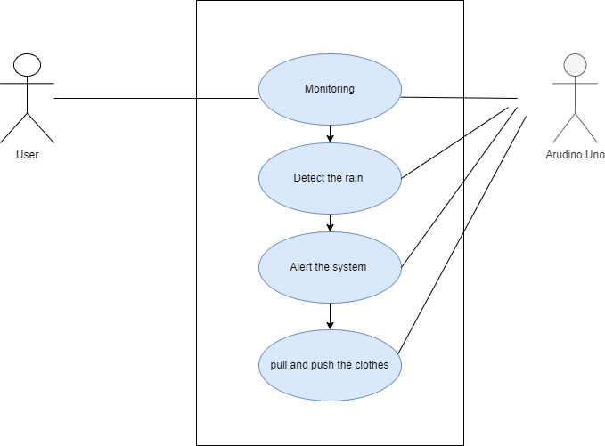

Figure 4.1 Use Case Diagram

11

**4.1.2CLASS DIAGRAM**

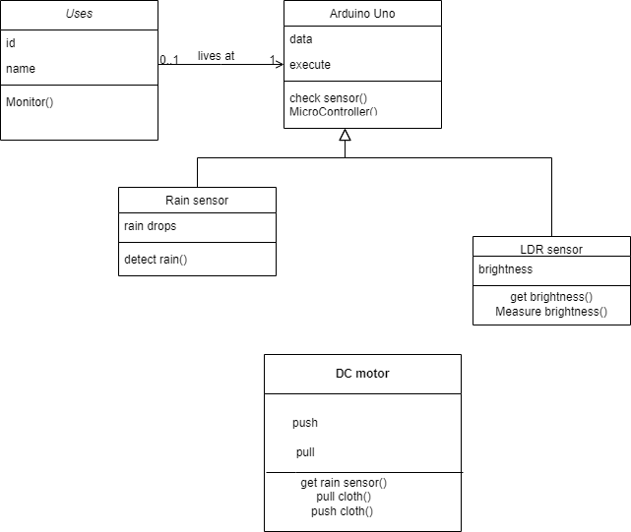

Figure 4.2 Class diagram

12

**4.1.3SEQUENCE DIAGRAM**

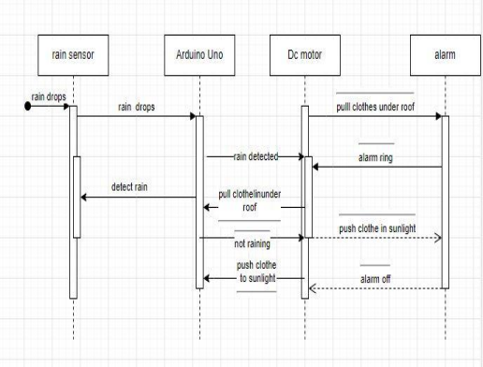

Figure 4.3 Sequence Diagram

13

**4.2 MODULES**

In the proposed system there are modules which are listed below,

**Modules**

The User module has six sub modules,

● Rain sensor module

● Smart Clothline controller module

● Motorized Clothline module

**4.2.1 MODULE DESCRIPTION**

**Rain sensor module:**

The rain sensor module/board is shown below. Basically, this board includes nickel coated lines and it works on the resistance principle. This sensor module permits to gauge moisture through analog output pins & it gives a digital output while moisture threshold surpasses.

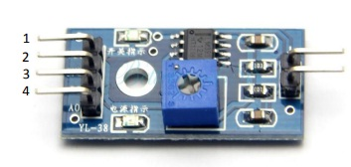

Figure 4.4 RAIN SENSOR MODULE

14

This module is similar to the LM393 IC because it includes the electronic module as well as a PCB. Here PCB is used to collect the raindrops. When the rain falls on the board,This sensor is a resistive dipole, and based on the moisture only it shows the resistance.

**Smart Clothesline Controller:**

A smart clothesline controller can be installed to control the movement of the clothesline based on weather conditions. The controller can be programmed to retract the clothesline or cover it with a shelter when it starts raining or when the wind speed exceeds a certain level. It can also be integrated with a weather forecast API to predict upcoming weather conditions and adjust the clothesline accordingly.

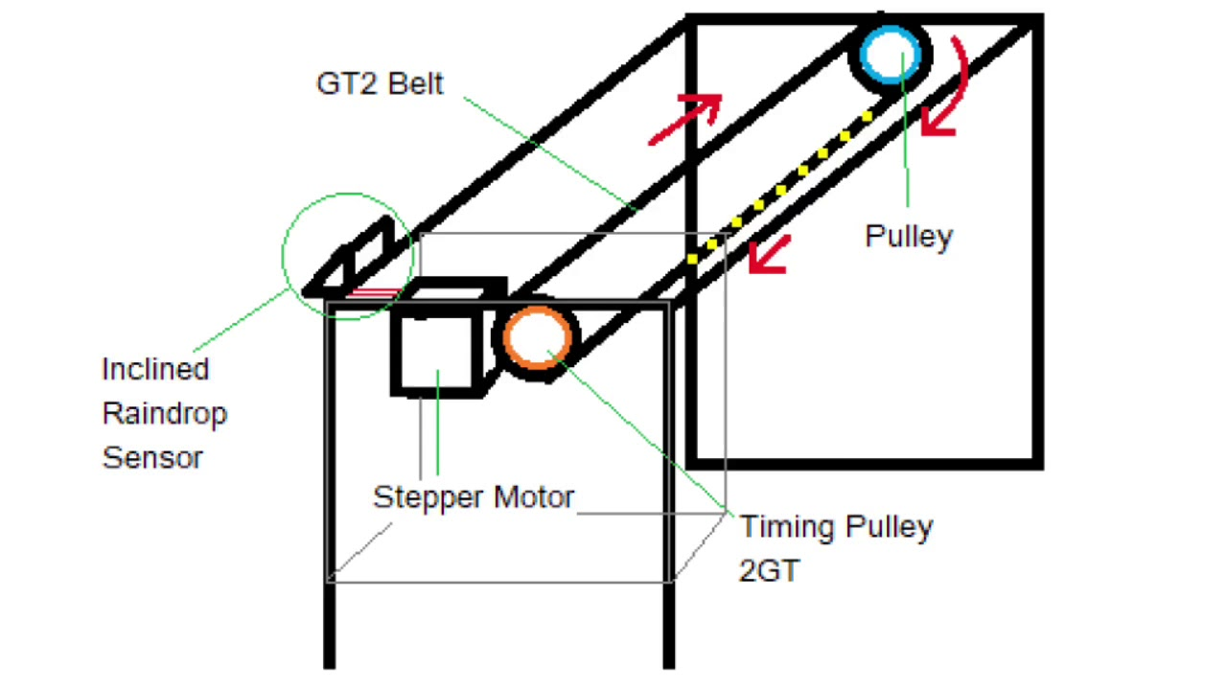

Figure 4.5 smart clothesline controller

**Motorized Clothesline:**

This module can be used to trigger the deployment of an umbrella or raincoat when the wearer enters a certain area, such as a building entrance. The module can detect the RFID tag on the clothing or on the wearer and activate the protection mechanism accordingly.

15

**CHAPTER 5**

**SYSTEM REQUIREMENTS**

**5.1 SOFTWARE REQUIREMENTS**

Software Requirements for Automatic protection clothes from rain using Internet of

Things is described below.

**ARDUINO IDE:**

The Arduino Software (IDE) makes it easy to write code and upload it to the board offline. We recommend it for users with poor or no internet connection. This software can be used with any Arduino board.There are currently two versions of the Arduino IDE, one is the IDE 1.x.x and the other is IDE 2.x. The IDE 2.x is new major release that is faster and even more powerful to the IDE 1.x.x. In addition to a more modern editor and a more responsive interface it includes advanced features to help users with their coding and debugging

[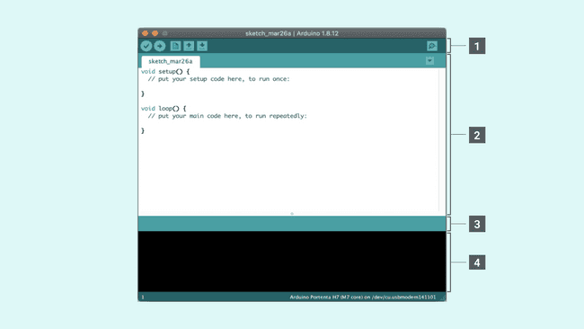](https://docs.arduino.cc/static/ebf961f81c305e826d52e3401863b48e/29114/arduino-ide-interface.png)

Figure 5.1 The Arduino Software IDE

16

**5.2 HARDWARE REQUIREMENTS**

Hardware Requirements for Automatic protection clothes from rain using Internet

of things is described below.

**ARDUINO UNO:**

Arduino Uno is an open-source microcontroller board based on the ATmega328P microcontroller chip. It is one of the most popular boards in the Arduino family and is widely used in hobbyist and educational projects.

The Arduino Uno board features 14 digital input/output pins (of which 6 can be used as PWM outputs), 6 analog inputs, a 16 MHz quartz crystal, a USB connection, a power jack, an ICSP header, and a reset button. It can be powered by either USB connection or an external power source.

The Arduino Uno board is programmed using the Arduino Integrated Development Environment (IDE), which is a user-friendly software platform that allows users to write, compile, and upload code to the board. The IDE supports a simplified version of the C++ programming language and provides a large library of pre-written code and examples that can be easily modified and

adapted to different projects.

The Arduino Uno board can be used for a wide range of projects, including robotics, home automation, data logging, and Internet of Things (IoT) applications. Its open-source nature and ease of use make it a popular choice for beginners and experienced makers alike.

17

**Rain sensor:**

A rain sensor is an electronic device that is used to detect the presence of rain or water. It is commonly used in automotive applications.Rain sensors operate on the principle of measuring the capacitance of water. When water comes into contact with the sensor, which triggers an output signal that can be used to activate a variety of systems or devices.

Rain sensors are typically made of materials that are sensitive to water, such as ceramic or polymer films. They can be mounted on a variety of surfaces, such as roofs, gutters, or pavements, and are often used in conjunction with other weather monitoring devices, such

temperature and humidity sensors.

In irrigation systems, rain sensors are used to prevent unnecessary watering when there is already sufficient moisture in the soil. They can also be used to control the amount of water used in a particular area, which can help to conserve water and reduce water bills.

In automotive applications, rain sensors are used to activate windshield wipers when rain is detected, providing increased visibility for the driver. They are often integrated into the windshield or rearview mirror and can be programmed to adjust the wiper speed and frequency based on the intensity of the rain.

Overall, rain sensors are an important component in various applications and provide a valuable function by detecting the presence of rain or water and triggering the appropriate response.

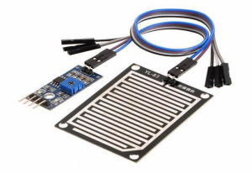

Figure 5.2 Rain sensor

18

**DC MOTOR:**

A DC motor is an electric motor that operates using direct current (DC) electricity. It converts electrical energy into mechanical energy through the interaction of magnetic fields. DC motors are commonly used in a wide range of applications such as robotics, electric vehicles, industrial machinery, and household appliances.

The basic structure of a DC motor consists of a stator, which is a stationary component containing the magnetic fields, and a rotor, which is a rotating component containing the armature and the commutator. When electric current is applied to the armature, a magnetic field

is generated that interacts with the magnetic field of the stator, causing the rotor to rotate.

DC motors can be classified into two main types: brushed and brushless. Brushed DC motors use brushes to transfer electrical power to the armature, while brushless DC motors use electronic commutation to switch the current to the different windings of the motor. Brushless DC motors are more efficient and have a longer lifespan than brushed DC motors, but they are also more expensive.

DC motors are versatile and can be controlled using various techniques, such as pulse-width modulation (PWM) and speed control. They are often used in conjunction with other components such as gearboxes, encoders, and controllers to provide precise and efficient motion control in various applications.

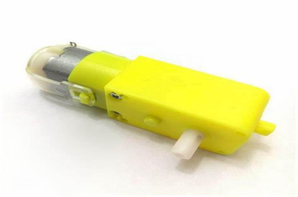

Figure 5.3 DC MOTOR

19

**BUZZER:**

A buzzer is an electronic component that produces sound when an electric signal is applied to it. It is a type of transducer that converts electrical energy into mechanical vibrations, which create sound waves that we can hear.

Buzzers can be classified into two main types: active and passive. Active buzzers contain an internal oscillator circuit that produces a specific tone when a voltage is applied, while passive buzzers require an external oscillator circuit to produce sound.

Buzzers can be found in a wide range of applications, such as alarms, timers, electronic games, and notification systems. They are commonly used as audible indicators in electronic devices and equipment, to alert users of a specific event or condition.

Buzzers come in different shapes and sizes, from small surface-mount devices to larger speakers. They can produce different types of sound, including continuous tones, beeps, and musical melodies.

Overall, buzzers are an important component in electronic circuits and provide an audible signal to alert users of various events or conditions.

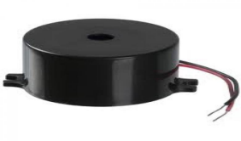

Figure 5.4 BUZZER

20

**LED:**

LED stands for "Light Emitting Diode." It is a semiconductor device that emits light when an electric current is passed through it. LEDs are commonly used as indicators, signal lights, and in various lighting applications.

LEDs offer many advantages over traditional light sources, such as incandescent and fluorescent bulbs. They are more energy-efficient, last longer, and are more durable, as they are not made of fragile glass and do not contain toxic materials such as mercury. Additionally, LEDs can be made in a wide range of colors, including red, green, blue, yellow, and white.

LEDs can be used in a variety of applications, including indoor and outdoor lighting, automotive lighting, electronic displays, and backlighting for screens. They are also commonly used in decorative lighting, such as for holiday decorations and string lights.

One of the main advantages of LEDs is their energy efficiency. They consume less energy than traditional bulbs, making them a more environmentally friendly and cost-effective lighting option. Additionally, LED lighting can be easily controlled and dimmed, allowing for greater customization and flexibility in lighting design.

Overall, LEDs are a versatile and efficient lighting solution that are widely used in various industries and applications.

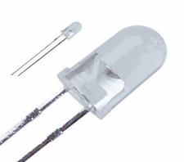

Figure 5.5 LED

21

**MICROCONTROLLER:**

A microcontroller is a small computer on a single integrated circuit (IC) chip that is designed to control a specific task or system. It consists of a central processing unit (CPU), memory (both volatile and non-volatile), and various input/output (I/O) peripherals, all integrated into a single chip.

Microcontrollers are commonly used in embedded systems, which are electronic systems that are part of a larger device or machine. They can be found in a wide range of applications, such as automotive systems, industrial control systems, home automation, and consumer electronics.

Microcontrollers are programmed using high-level programming languages, such as C or C++, and often use specialized software tools called Integrated Development Environments (IDEs) to aid in the development and debugging of code. Microcontrollers are also programmed using firmware, which is a type of software that is stored in non-volatile memory.

One of the main advantages of microcontrollers is their small size and low power consumption, making them ideal for use in small, portable devices that have limited power resources. They are also highly flexible, as they can be programmed to perform a wide range of tasks, from simple control tasks to complex algorithms and data processing.

Overall, microcontrollers are an essential component in modern electronics, providing a powerful and flexible solution for a wide range of embedded system applications.

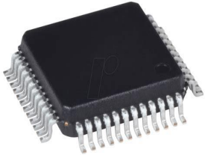

Figure 5.6 MICROCONTROLLER

22

**MOTOR DRIVER:**

A motor driver is an electronic circuit that is used to control the speed and direction of an electric motor. It provides the necessary power and control signals to drive the motor and can be used in a wide range of applications, such as robotics, automation, and industrial control systems.

Motor drivers typically consist of a power stage and a control circuit. The power stage consists of one or more transistors or MOSFETs that switch on and off to provide power to the motor.The control circuit generates the necessary control signals to switch the transistors or MOSFETs, which control the speed and direction of the motor.

Motor drivers can be classified into two main types: DC motor drivers and stepper motor drivers. DC motor drivers are used to control the speed and direction of DC motors, while stepper motor drivers are used to control the position and speed of stepper motors.

Motor drivers can be controlled in a variety of ways, including analog, digital, and pulse-width modulation (PWM) signals. PWM is a popular method of motor control, as it allows for precise control over the speed and direction of the motor, while also reducing power consumption and heat generation.

Overall, motor drivers are an important component in motor control systems, providing the necessary power and control signals to drive and control electric motors.

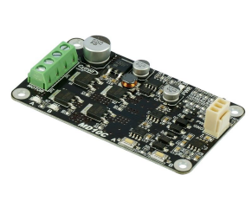

Figure 5.7 MOTOR DRIVER

23

**CHAPTER 6**

**IMPLEMENTATION AND RESULT**

**6.1 IMPLEMENTATION ANDROID STUDIO CODE**

Android Studio is an integrated development environment (IDE) designed specifically for developing Android applications. It includes a set of tools and features that make it easier for developers to create, test, and deploy Android apps. The IDE provides a user-friendly interface for developers to write code, design user interfaces, and test their applications. It also supports a wide range of programming languages and features, including code completion, refactoring, and debugging tools.

Some of the key features of Android Studio include. Android Studio is the official Integrated Development Environment (IDE) for android application development. Android Studio provides more features that enhance our productivity while building Android apps, it comprises of five levels.

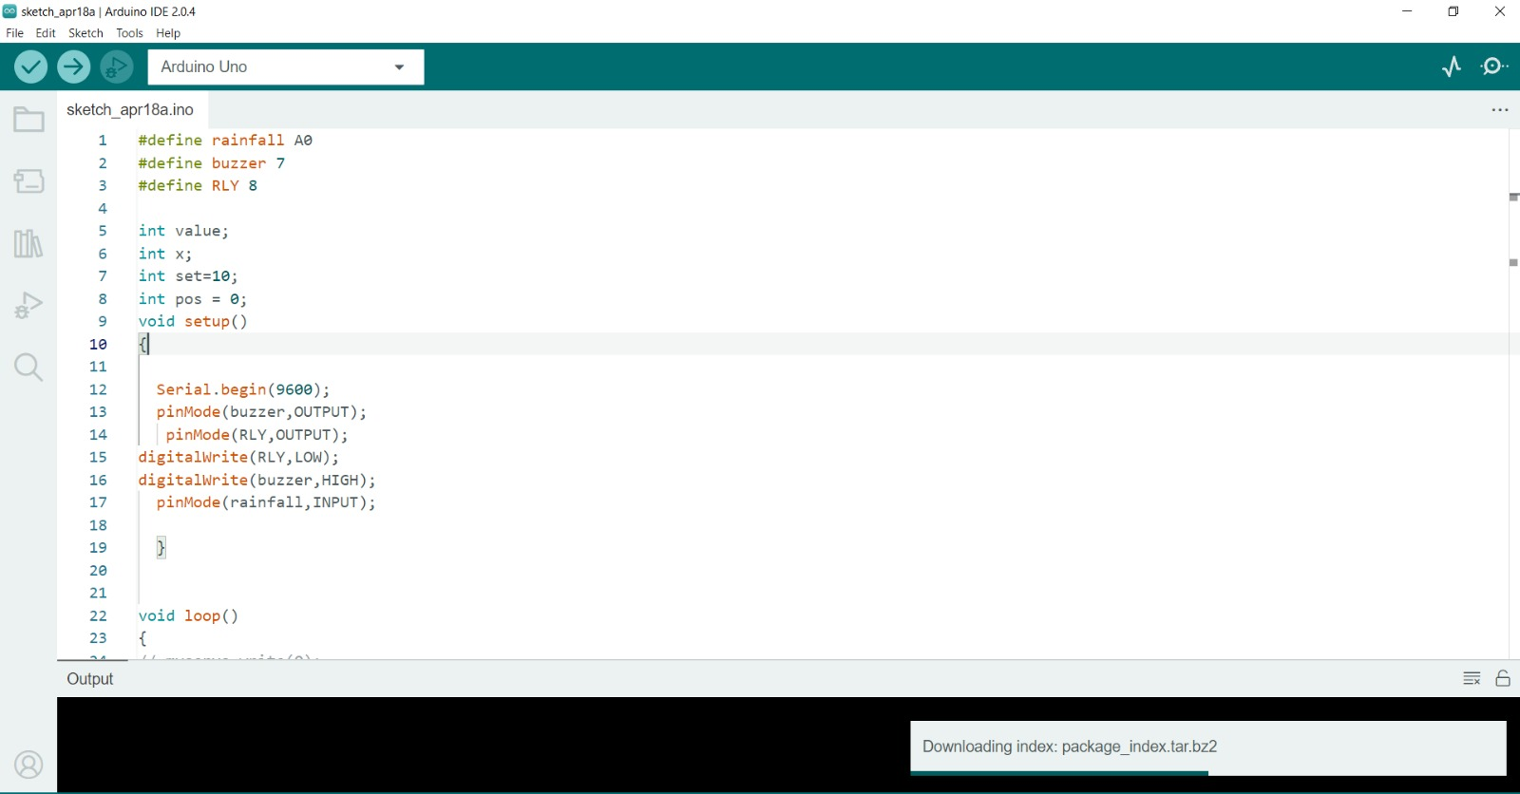

Figure 6.1 Arduino Software IDE

24

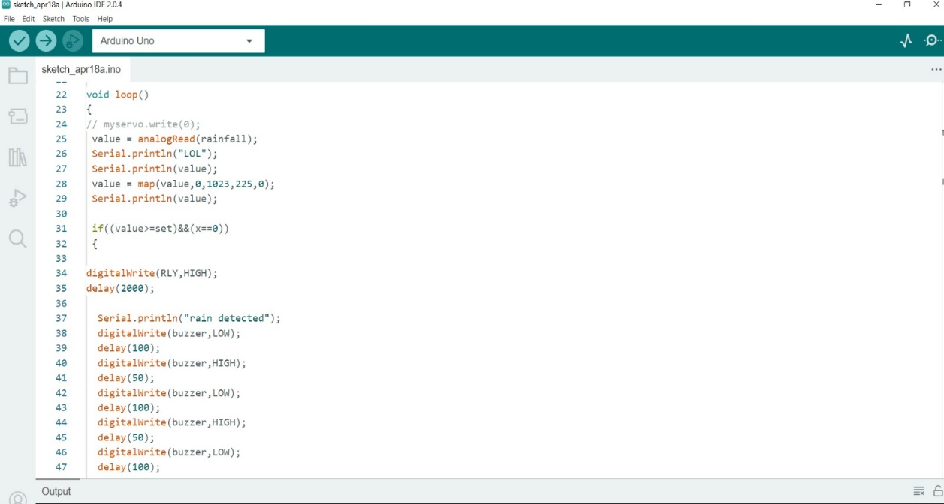

Figure 6.2 Code on Arduino Software IDE

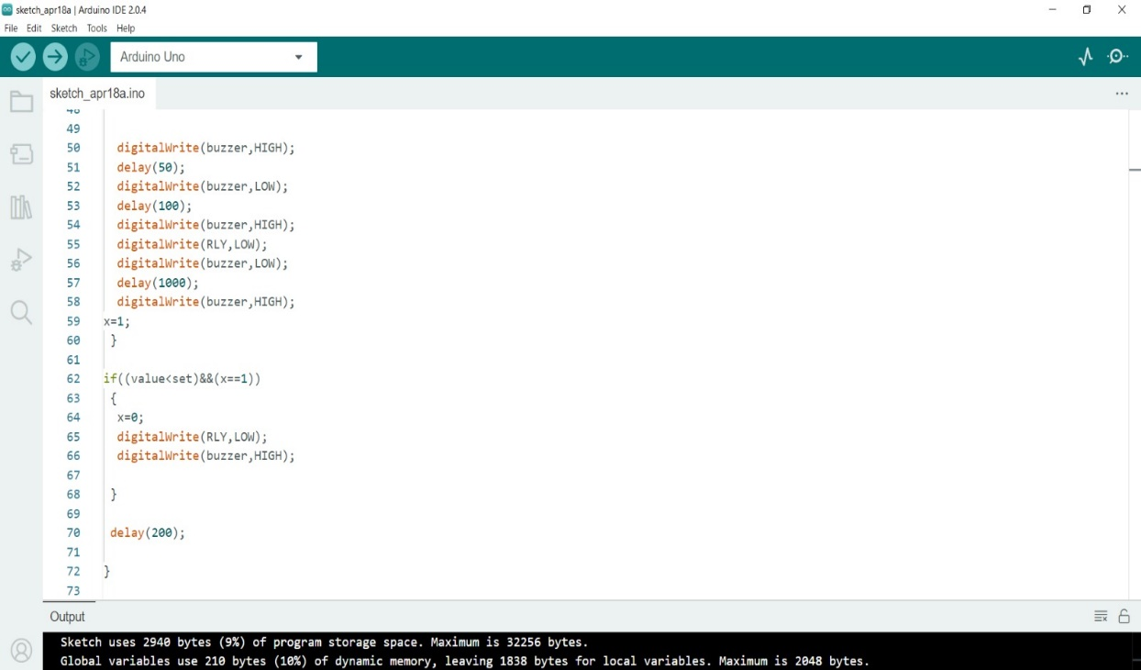

Figure 6.3 Code on Arduino IDE

25

**6.2 EXPERIMENTAL RESULT**

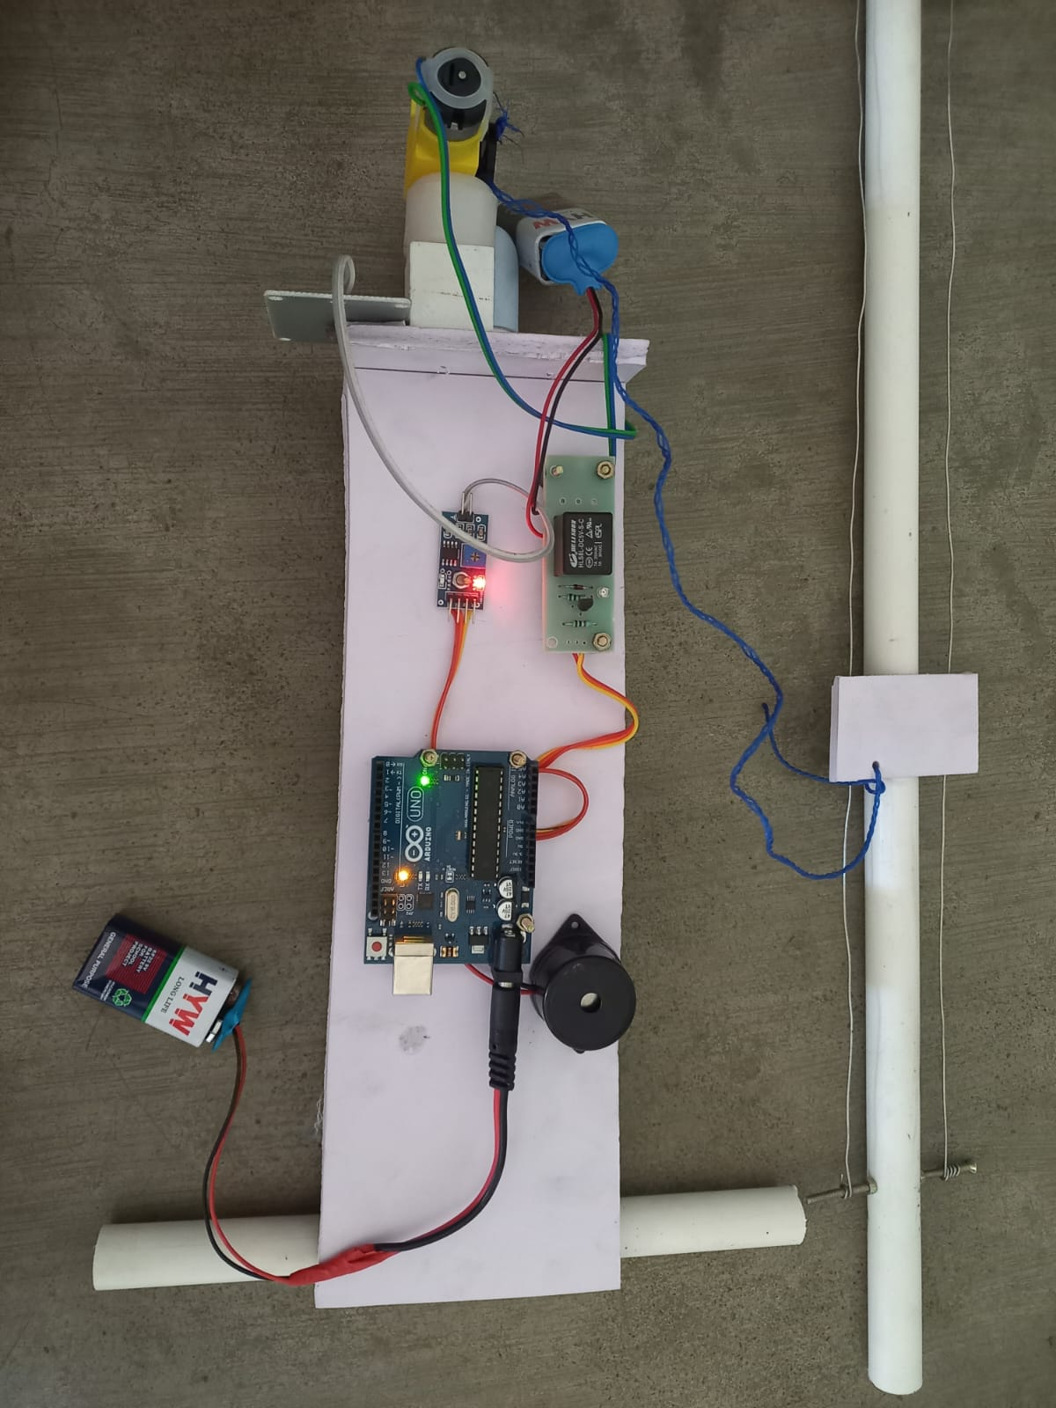

Figure 6.4 Sensors amd arduino connection on prototype

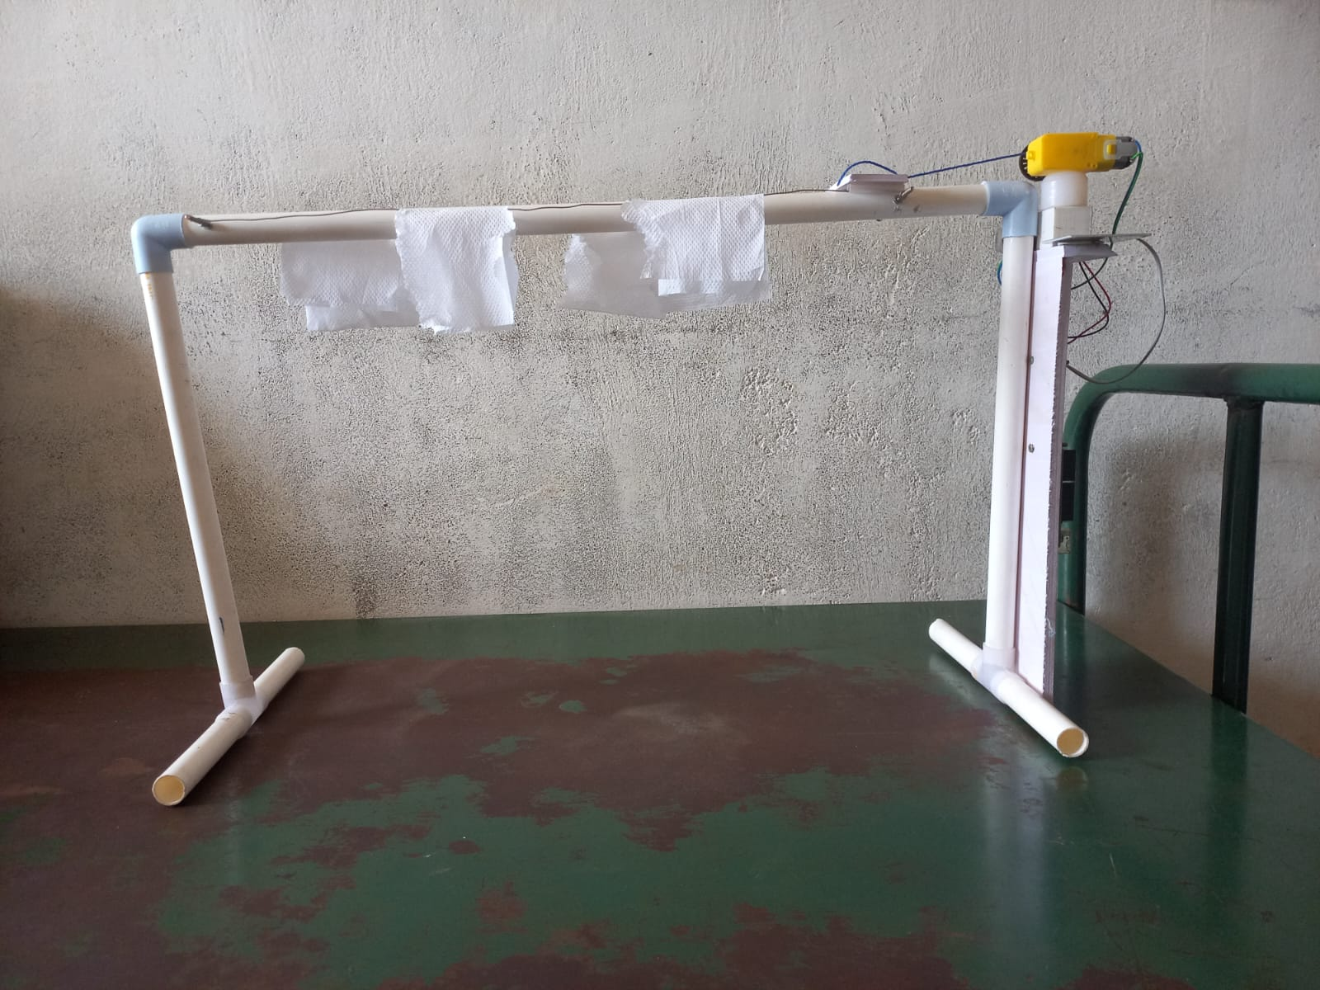

Figure 6.5 Prototype Model

26

**CHAPTER 7**

**CONCLUSION AND FUTURESCOPE**

**7.1 CONCLUSION**

At the end of this project we were able to design a system, which can solve the problem better idea for drying wet clothes especially in rainy season. If Clothes are washed and dry by the washing machine there will be wetness in the clothes because of that bad smell is occurred. So that irritated and disturbing themselves. And there may be skin problems. Finally this system avoid above problems and gives good result. This Project enables us to carry towards the new technology. In this project we protect our clothes in rainy season automatically without need any human involvement. So it provides the comfort ability, reduces the human effort and saves the time. We can easily used in home, office and wherever it can be used based on our requirement .So it makes life easy to our next generation.

**7.2 FUTURE ENHANCEMENTS**

1. Voice-activated control
2. Solar-powered system
3. Machine learning
4. App-based control
5. Integrated clothes drying system

27

**Voice-activated control:**

In the future, it may be possible to control the automatic protection of clotheslines from rain using voice commands. This could be especially useful for people with disabilities or mobility issues.

Solar-powered system: A solar-powered system could be developed to power the automatic protection of clotheslines from rain. This could reduce the need for electricity and make the system more eco-friendly.

**Machine learning:**

Machine learning algorithms could be used to predict rain patterns and optimize the automatic protection of clotheslines. By analyzing data from weather sensors, machine learning models could predict when rain is likely to occur and adjust the system accordingly.

**App-based control:**

An app-based control system could be developed to allow users to control the automatic protection of their clotheslines from their smartphones. This could provide greater flexibility and convenience for users.

**Integrated clothes drying system:**

An automatic protection system could be integrated with a clothes drying system to provide a complete solution for drying clothes outdoors. The system could adjust the clothesline height and retract the clothesline when rain is detected, and then deploy it again when the rain stops.

28

**REFERENCES**

[1] Automatic Rain Sensing Wiper System for Cars, by N. Narmadha,P. Vishnu, K. Gopinath, and K. Kumaravel, International Journal of Innovative Technology and Exploring Engineering, vol. 8, no. 9, pp. 168-172, 2019.

[2] Smart Raincoat with Automatic Rain Protection, by S. Rajasekar and S. Karthik. International Journal of Innovative Research in Science, Engineering and Technology, vol. 6, no. 3, pp. 112-116, 2017.

[3] Rain Sensing Automatic Car Wiper Control System, by G. Deepak, G. Prasanna, K. Ramesh, and K. Prasanth, International Journal of Advanced Research in Electrical, Electronics and Instrumentation Engineering, vol. 4, no. 9, pp. 7884-7891, 2015.

[4] Development of Automatic Rain Wiper System for Automobiles, by S. S. Sivakumar, S. Saravana Kumar, and A. Karthikeyan, International Journal of Engineering Research and Applications, vol. 3, no. 5, pp. 1225-1228, 2013.

[5] Design and Implementation of an Automatic Rain Sensing System for a Smart Umbrella,

by Y. K. Lee, T. H. Kim, and Y. H. Kim, Sensors, vol. 18, no. 8, 2018.

[6] Y. Liu, H. Zhang, and J. Wang, "Design and Implementation of an Intelligent Rain-Proof System for Outdoor Clothing," IEEE Transactions on Industrial Informatics, vol. 16, no. 6, pp. 4071-4079, 2020.

[7] S. Shinde, A. S. Raut, and S. R. Surve, "Smart Raincoat System Using Arduino," International Journal of Engineering and Advanced Technology (IJEAT), vol. 9, no. 6, pp. 341- 346, 2020.

[8] N. K. Yadav, R. Bhattacharjee, and P. Bhattacharyya, "A Portable Rain Protection System Using IoT," International Conference on Intelligent Sustainable Systems (ICISS), pp. 586-590, 2020.

[9] J. S. Kim, J. S. Yoon, and J. W. Choi, "Design of a Smart Raincoat with Water-Sensing Function," Journal of the Korean Society of Clothing and Textiles, vol. 44, no. 3, pp. 297-307, 2020.

[10] M. K. Laha, S. P. Raja, and V. Chandrasekhar, "Smart Raincoat: A New Approach towards Rain Protection," International Journal of Innovative Technology and Exploring Engineering (IJITEE), vol. 8, no. 8S, pp. 539-542, 2019.

29

[11]. S. Dharmadhikari, N. Tamboli, N. Gawali and N.N. Lokhande “Automatic Wiper System” in International Journal of Computer Technology and Electronics Engineering Vol. 4, No. 2, April 2014 pp.15-18.

[12]. M. Ucar, H. Ertunc and O. Turkoglu, “The Design and Implementation of Rain Sensitive Triggering System for Windshield Wiper Motor” In IEEE International Electric Machines & Drives Conference, 2001, pp. 329-336.

[13]. Introduction to microcontroller by MAZIDI and AYALA.

[14]. [www.ePlastics.com/Plexiglass](http://www.ePlastics.com/Plexiglass).

[15]. Shinichi KATO* Toshinori YAGI* “Development of a Rain-Light Sensor” Technical Review 2008.

[16]. Kirk Martinez et al., “Environmental Sensor Networks”, Published by the ieee computer society, aug 2004, doi: 0018-9162/04, pp50- 56.

[17]. Hagit Messer et al., “Environmental Sensor Networks Using Existing Wireless Communication Systems for Rainfall and Wind Velocity Measurements”, IEEE Instrumentation & Measurement Magazine, april 2012, 32-38.

[18]. J. Schuster and W. Czarnocki, “Automotive pressure sensors: Evolution of a micromachined sensor application,” in SAE Int. Truck Bus Mtg., Cleveland, OH, Nov. 17, 1997, Paper 973 238.

30

**APPENDICES**

A paper on “Automatic protection of clothes from rain” is submitted in Suranaree Jouneral of Science and Technology